|  |
| --- |
| SHARP |
| Driver Configuration Guide |
| Windows Server 2008 Standard – 32bit |

|  |
| --- |
|  |

**Please read**

* The explanations in this Guide assume that the person who will install the product and the users of the product have a working knowledge of Microsoft® Windows®.
* For information about installation, please view the Installation Guide (PDF format) that is included in this software.
* For information on the operating system, please refer to your operating system manual or the online Help function.
* The explanations of screens and procedures in this Guide are for Windows® 2008 32Bit. The screens may vary depending on your Windows® version and settings.

**Warranty**

While every effort has been made to make this Guide as accurate and helpful as possible, SHARP Corporation makes no warranty of any kind with regard to its content.

All information included herein is subject to change without notice. SHARP is not responsible for any loss or damages, direct or indirect, arising from or related to the use of this Administrator’s Guide.

**© 2011 Sharp Electronics Corporation**

All rights reserved. Reproduction, adaptation or translation without prior written permission is prohibited, except as allowed under copyright laws.

**Trademark acknowledgments**

* Microsoft® Windows® operating system is a trademark or copyright of Microsoft Corporation in the U.S.A. and other countries.
* Windows® 2008, Windows® XP and Windows® 7 are trademarks or Copyrights of Microsoft Corporation in the U.S.A. and other countries.
* Intel and Pentium are trademarks or registered trademarks of Intel Corporation or its subsidiaries in the United States and other countries.
* IBM and PC/AT are trademarks of International Business Machines Corporation.
* Sharp® is a registered trademark of Sharp Corporation.
* All other trademarks and copyrights are the property of their respective owners.

**SOFTWARE LICENSE**

The SOFTWARE LICENSE will appear when you install the software. By using all or any portion of the software, you are agreeing to be bound by the terms of the SOFTWARE LICENSE.

Table of Contents

Section IIntroduction 5

*Introduction* 6

1. Adding and Configuring Standard TCP/IP Port 8

Table of Figures

Figure 1: Start Menu 8

Figure 2: Devices and Printers 9

Figure 3: Add Printer 10

Figure 4: Add Printer 11

Figure 5: Choose a printer port 12

Figure 6: Type a printer hostname or IP address 13

Figure 7: Additional port information required 14

Figure 8: Configure Standard TCP/IP Port Monitor 15

Figure 9: Additional port information required 16

Figure 10: Install the printer driver 17

Figure 11: Install From Disk 18

Figure 12: Install the printer driver 19

Figure 13: Type a printer name 20

Figure 14: Windows Security 21

Figure 15: Printer Sharing 22

Figure 16: Add Printer 23

# Section IIntroduction

## *Introduction*

This document covers the Configuration of following items on Windows Server 2008 R2 64 bit.

1. **Adding and Configuring Standard TCP/IP Port**

***Notes:***

1. You should be “**Administrator**” of the system to install/configure.
2. Install the appropriate printer driver provided by Sharp, Accounting plus Software supports following drivers.

|  |  |  |  |  |  |  |
| --- | --- | --- | --- | --- | --- | --- |
| **Device** | **Drivers** | | | | | |
| **Color** | PCL5e | PCL6 | PS | UPD | Eco | MAC |
| MX-2600N/3100N |  | **x** | **x** | **x** | **x** | **x** |
| MX-4100N/4101N/5001N |  | **x** | **x** | **x** | **x** | **x** |
| MX-C311/C401  DX-C311/C401 |  | **x** | **x** | **x** | **x** | **x** |
| DX-C310/DX-C400 |  | **x** | **x** | **x** | **x** | **x** |
| MX-C400P | **PCL5C** | **x** | **x** | **x** | **x** | **x** |
| **B&W** | PCL5e | PCL6 | PS | UPD | Eco | MAC |
| MX-M283N/M363N/  M453N/M503N | **x** | **x** | **x** | **x** | **x** | **x** |
| MX-B401 | **x** | **x** | **x** | **x** | **x** | **x** |
| MX-B400P | **x** | **x** | **x** | **x** | **x** | **x** |
| M623/M753N | **x** | **x** | **x** | **x** | **x** | **x** |

# Adding and Configuring Standard TCP/IP Port

* 1. Click on **Start >> Control Panel**

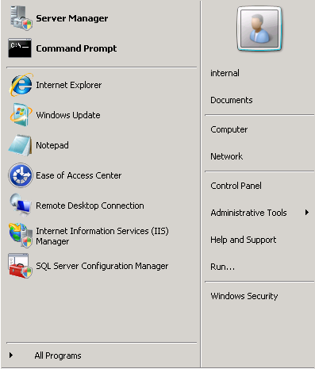

Figure 1: Start Menu

* 1. Click on “**Printers**”.

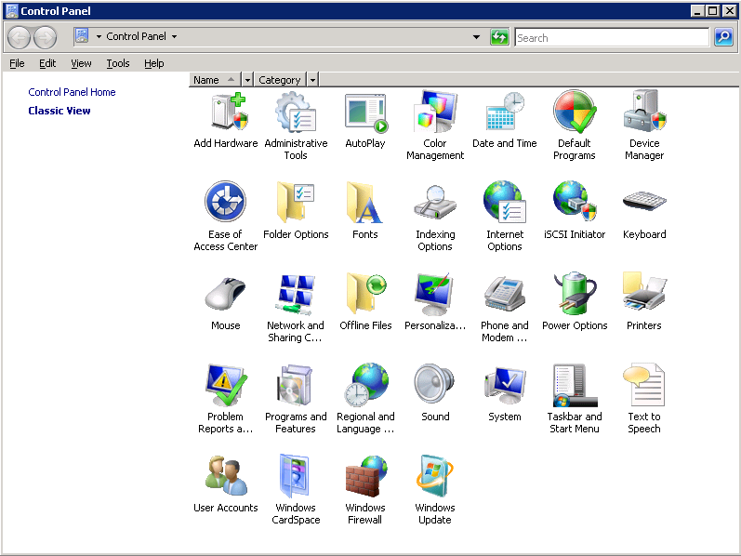

Figure 2: Control Panel

* 1. Click “**Add a Printer**”.

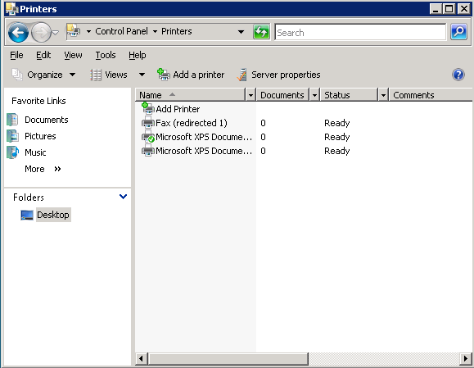

Figure 3: Printers

* 1. Click “**The printer that I want isn’t listed**”.

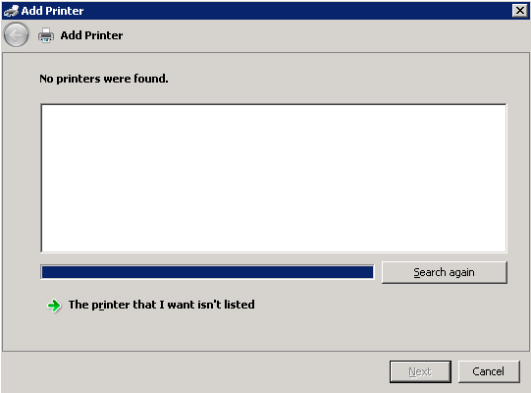

Figure 4: Add Printer

* 1. Select “Add a Printer using a TCP/IP address **”**
  2. Click “**Next**”.

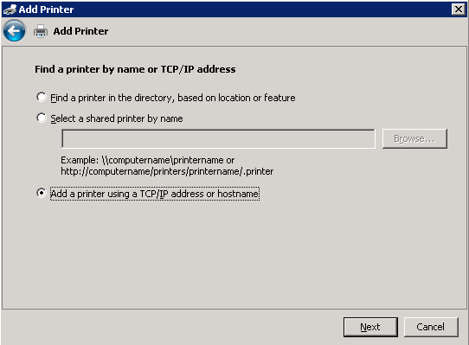

Figure 5: Add Printer

* 1. Select “**TCP/IP Device**” from Device type Dropdownlist.
  2. Enter “Accounting Plus Software Server IP Address” in “**Hostname or IP address**” Textbox.
  3. Click “**Next**”.

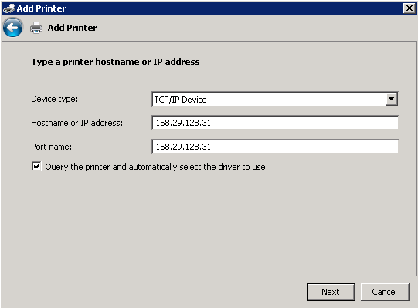

Figure 6: Type a printer hostname or IP address

* 1. Select “**Custom**” Radio button.
  2. Click “**Settings**”.

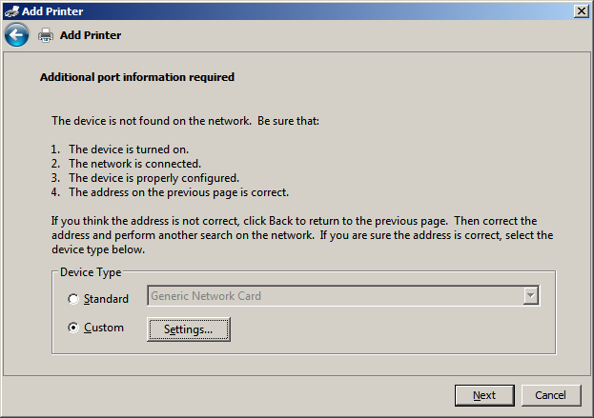

Figure 7: Additional port information required

* 1. Select “**Raw**” radio button in Protocol section.
  2. Enter port number “**8090**” in Port number Textbox.
  3. Click “**Ok**”

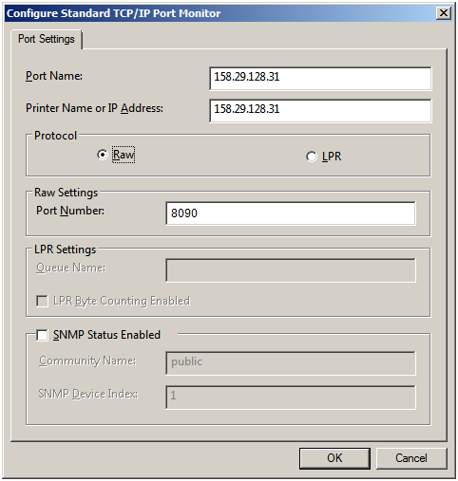

Figure 8: Configure Standard TCP/IP Port Monitor

* 1. Click “**Next**”.



Figure 9: Additional port information required

* 1. Click “**Have Disk…**”

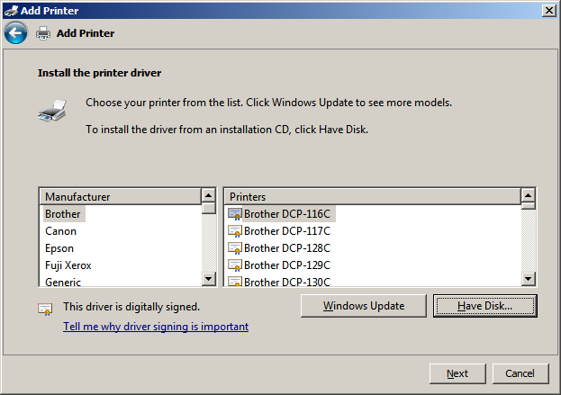

Figure 10: Install the printer driver

* 1. Click “**Browse**”.
  2. Select the “**.inf file**” from CD or System location.
  3. Click “**Open**”.
  4. Click “**OK**”.

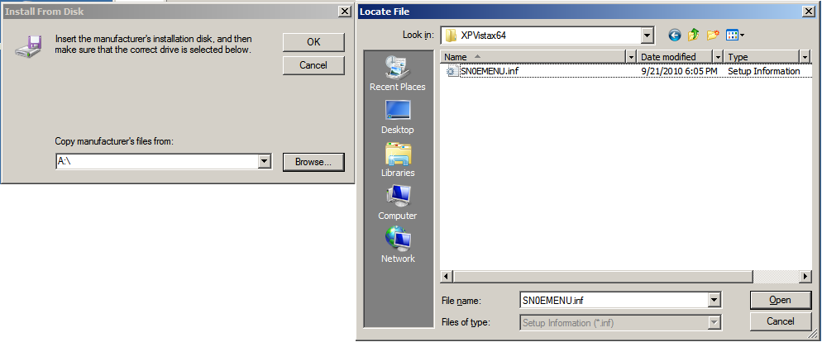

Figure 11: Install From Disk

* 1. Click “**Next**”.

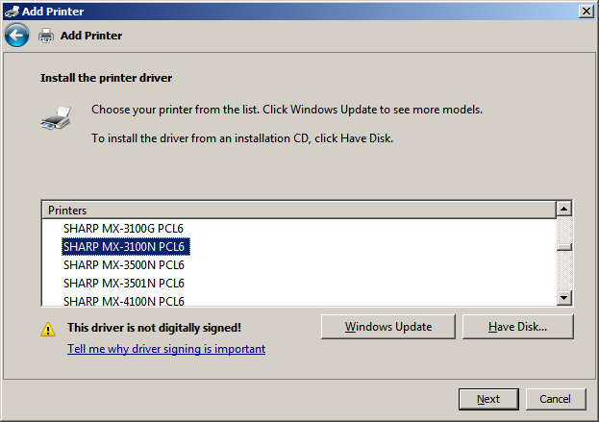

Figure 12: Install the printer driver

* 1. Click “**Next**”

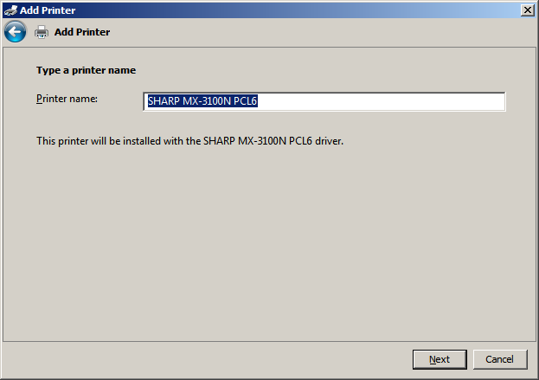

Figure 13: Type a printer name

* 1. Click “**Install this driver Software anyway**”

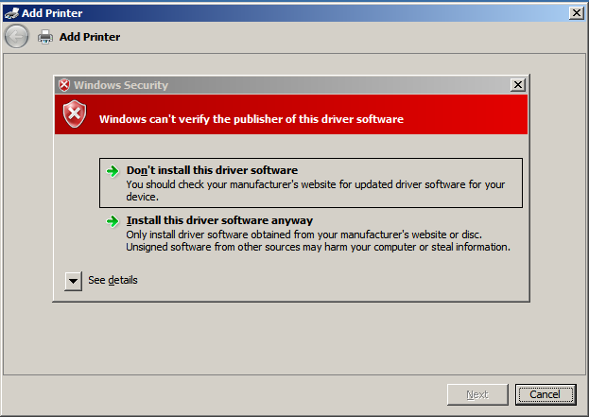

Figure 14: Windows Security

* 1. Click “**Next**”

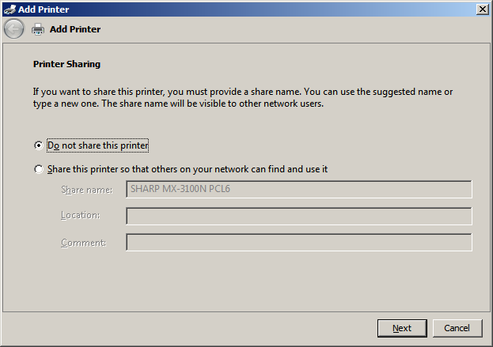

Figure 15: Printer Sharing

* 1. Click “**Finish**”.

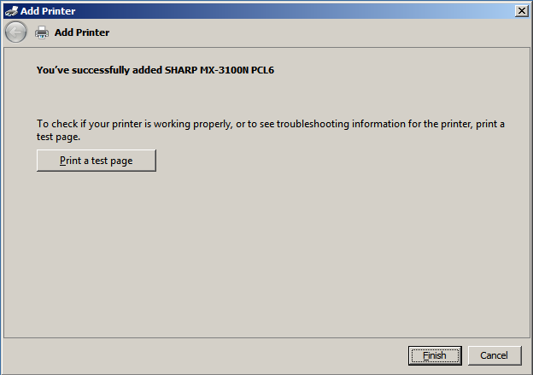

Figure 16: Add Printer